Quarter 1 Prism

**Samuel Pacheco**

**Summary:**

Throughout the first quarter, I was able to contribute by collaborating with my partners throughout the allotted time by brainstorming ideas for our boss rush prism game development. During this time, I was able to learn how to setup and maneuver through game development applications, which involved getting introduced to GitHub, Unity, .NET, and VS Code in the game development side of things. Lastly, I was able to manage a GitHub pull request that brought forth several changes to the current state of our Prism game.

**Week 1 and 2: Brainstorm Ideas**

**Summary:**

During this time our team was bringing forth ideas on how we would like our game design to look like and what mechanics we wanted to have throughout the games development process. This was thought out in a way that would make every user story of the game fun and enjoyable for the user throughout the play time. During this period, I was asked on my input on what the game’s damage and attack system mechanics should work out. In the end placing my vote on a color system that would change the game at every stage the player was at.

**Week 2: User Stories, Game Development Walkthrough, and Jira Setup**

**User Stories:**

During week one of our Prism game development, I was tasked with creating user stories for any interactivity possible in our game. During this process I had the help of my fellow groupmates Figma designs so that nothing was left out. This Google Doc described events the player was going to witness firsthand such as attacking, defending, damage, game settings, item pickups, etc.

[LINK: Interactivity Google Doc](https://docs.google.com/document/d/13ZpvuUusUEGBB86XY4YkES-18FFIu3fXnDVvT8Q7fqc/edit?usp=sharing)

**

**Game Development Environment Setup and Walkthrough:**

Since I am starting without any knowledge in game development, I had to go through the process of setting up applications which I would need throughout the semester. This included setting up VS Code, Unity, and GitHub together so that the development process could begin on our Prism game. During this time, I was also being showcased the rundown of how game development took place using all three of the following applications by my partners. This included explanations on how assets in Unity worked and how scripts could be assigned to any given item to bring functionality.

**Jira Setup:**

Throughout week 2, Jira was introduced and utilized to create a formidable lineup of tasks that would need to be completed. In Jira we utilized the Epics category for vague items such as player and enemy, these would only then be broken down into specifics under tasks within the epics. For instance, a task for a player would included something in the likes of anything the player could do such as move or pickup an item. Tasks could then be broken down into subtasks if they were deemed too difficult to complete in full. This provided us with a template so that continuous integration was being done on our Prism game in a timely manner. Lastly, during this week my group was able to assign our first sprint and assigned tasks to each other. I was tasked with bringing forth a change in our camera movement and integrate a health system for our player.

[LINK: Boss Rush Prism Jira](https://jrsite.atlassian.net/jira/software/projects/BRP/boards/4/roadmap)

**

**Week 3 and 4: Starting and Finishing our First Jira Sprint**

**Summary:**

Through weeks 3 and 4, my group spent time collaborating with each other so that we could begin and finish our first Jira sprint in a timely manner. This meant beginning to progress our games code and unity project. In the Jira, I was tasked with implementing a camera movement and player health system.

**Code:**

For our first sprint I mainly worked with the Sample Scene to test and implement the tasks I was assigned. With that in mind I primarily worked with the CameraMovement.cs and HealthBar.cs files that are now in our most active GitHub project.

**CameraMovement.cs:**

Previously our game camera was at a lock and allowed for the player to leave the viewable area. The idea we had agreed on was that we wanted the camera to stick with the player everywhere he went in the game. This was done by creating a script placed in the Main Camera of the game, inside of this script I included the player to be the position of the camera, therefore, producing the camera movement we expected.

**HealthBar.cs:**

Previously our Prism game had no health system implemented into it. I was tasked with creating one and assigning it to a health bar UI that was visible to the user. This task was quite lengthy and took the guidance of my groupmates to fully complete. To implement this we had to create a working health system script on the player that would give him a maximum 100 points of health at the beginning of the game, but in the event of an attack damage would be done. Along with this, the player would gain health at a much lower rate, so long as they were out of the enemy zone. For my pull request, I was able to input an enemy star that would cause the player to lose health if he were to walk over it to showcase the health system. In summary, the player took on a health system script that would require the health bar on the canvas for the UI to showcase.

**Code Product:**

**GitHub Pull Request:**

Figure : This figure showcases my pull request being merged into main.

**Camera Movement:**

Figure 2: In this figure we can see the camera before the new implementation, locked on to just a single frame.

Figure 3: In this figure we can see that the camera is now following the player.

**Health System:**

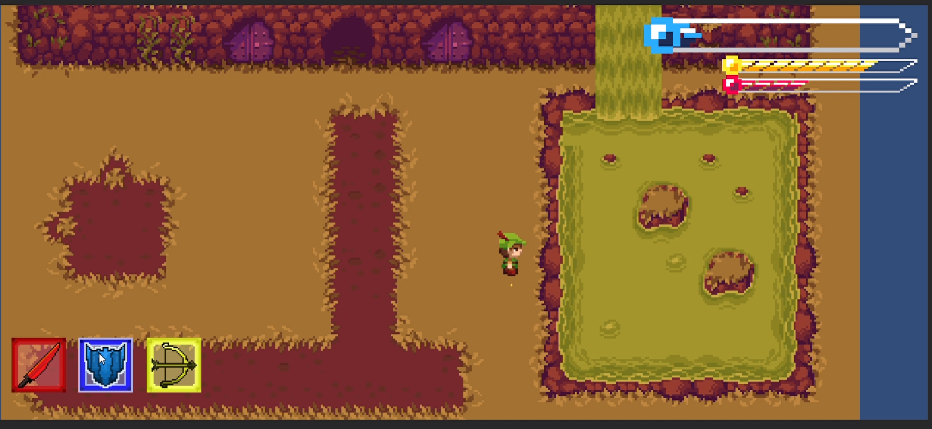

Figure : Previously there was no health system and showcased no health bar.

Figure : This figure showcases the player standing over the enemy star, which is causing the player to lose health.

Figure : This figure showcases the player out of harm’s way, replenishing health.